Smt. Chandaben Mohanbhai Patel Institute of Computer Applications

Sub: CA314: Object Oriented Programming through JAVA

Practical Assignment-2

Introduction to Java

Submitted By: SHIVAM USTURGE (19BCA063)

1. Write a java code to find the max among three numbers using command line argument.

package cmpica;

class Max{

public void GetMax(int no1, int no2, int no3)

{

if ( no1>no2 && no1>no3 ){

System.out.println("Maximum Amoung Three numbers is: "+no1);

}

else if ( no2>no3 ){

System.out.println("Maximum Amoung Three numbers is: "+no2);

}

else {

System.out.println("Maximum Amoung Three numbers is: "+no3);

}

}

}

public class ass2_1findmax {

public static void main(String args[])

{

int a= Integer.parseInt(args[0]);

int b= Integer.parseInt(args[1]);

int c= Integer.parseInt(args[2]);

Max m = new Max();

m.GetMax(a, b, c);

}

}

INPUT:2,4,5

OUTPUT:

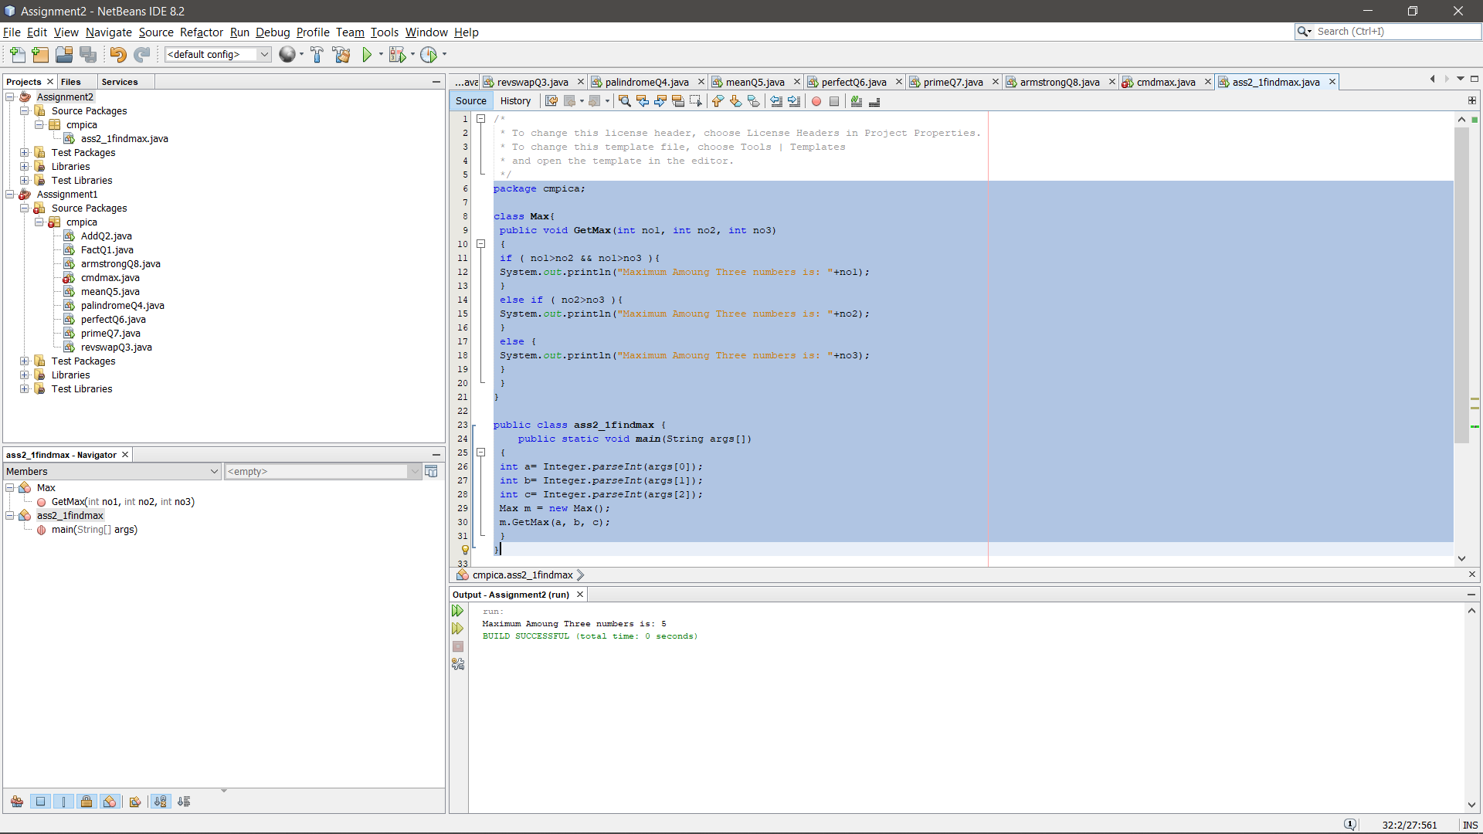

1. Write program to find sum of even digits using comman line arguement. Input 23617 output 2+6=8.

package cmpica;

class Evensum{

public void GetEvenSum(int no1)

{

int sum=0;

int temp,r;

temp=no1;

while (no1>0)

{

r= no1%10;

if (r%2==0)

{

sum=sum+r;

}

no1=no1/10;

}

System.out.println("Sum of Even Digits of Given Number is: "+sum);

}

}

public class ass2_2sumeven

{

public static void main(String args[])

{

int no1= Integer.parseInt(args[0]);

Evensum es = new Evensum();

es.GetEvenSum(no1);

}

}

INPUT:1234

OUTPUT: 2+4=6

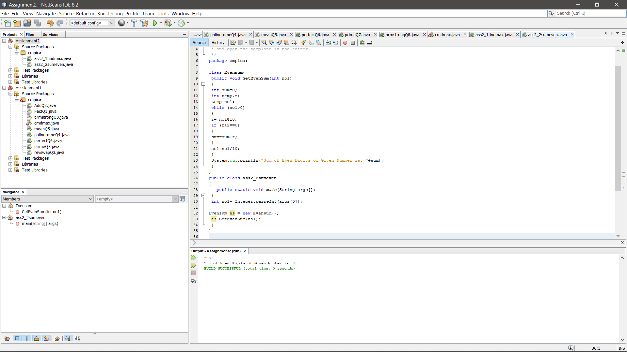

1. Write a program to accept student information such as roll no, name, course and display the same.

package cmpica;

import java.util.Scanner;

public class ass2_3studinfo {

public static void main(String args[])

{

Scanner sc= new Scanner(System.in);

System.out.println("Enter Your Roll No.: ");

int roll_no=sc.nextInt();

System.out.println("Enter Your Name: ");

String name=sc.nextLine();

sc.nextLine();

System.out.println("Enter Your Course Name: ");

String course=sc.nextLine();

System.out.println("Your Roll No.: "+roll_no);

System.out.println("Your Name: "+name);

System.out.println("Your Course Name: "+course);

}

}

OUTPUT:

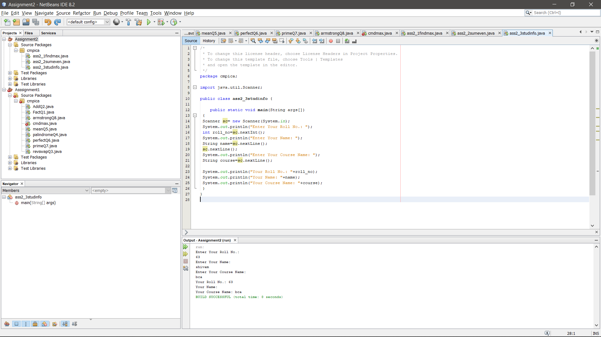

1. Write a java code convert Decimal Number into Binary Number using comand line arguement.

package cmpica;

public class ass2_3dec {

public static void main(String args[])

{

int no=Integer.parseInt(args[0]);

System.out.println(Integer.toBinaryString(no));

}

}

INPUT:

OUTPUT:

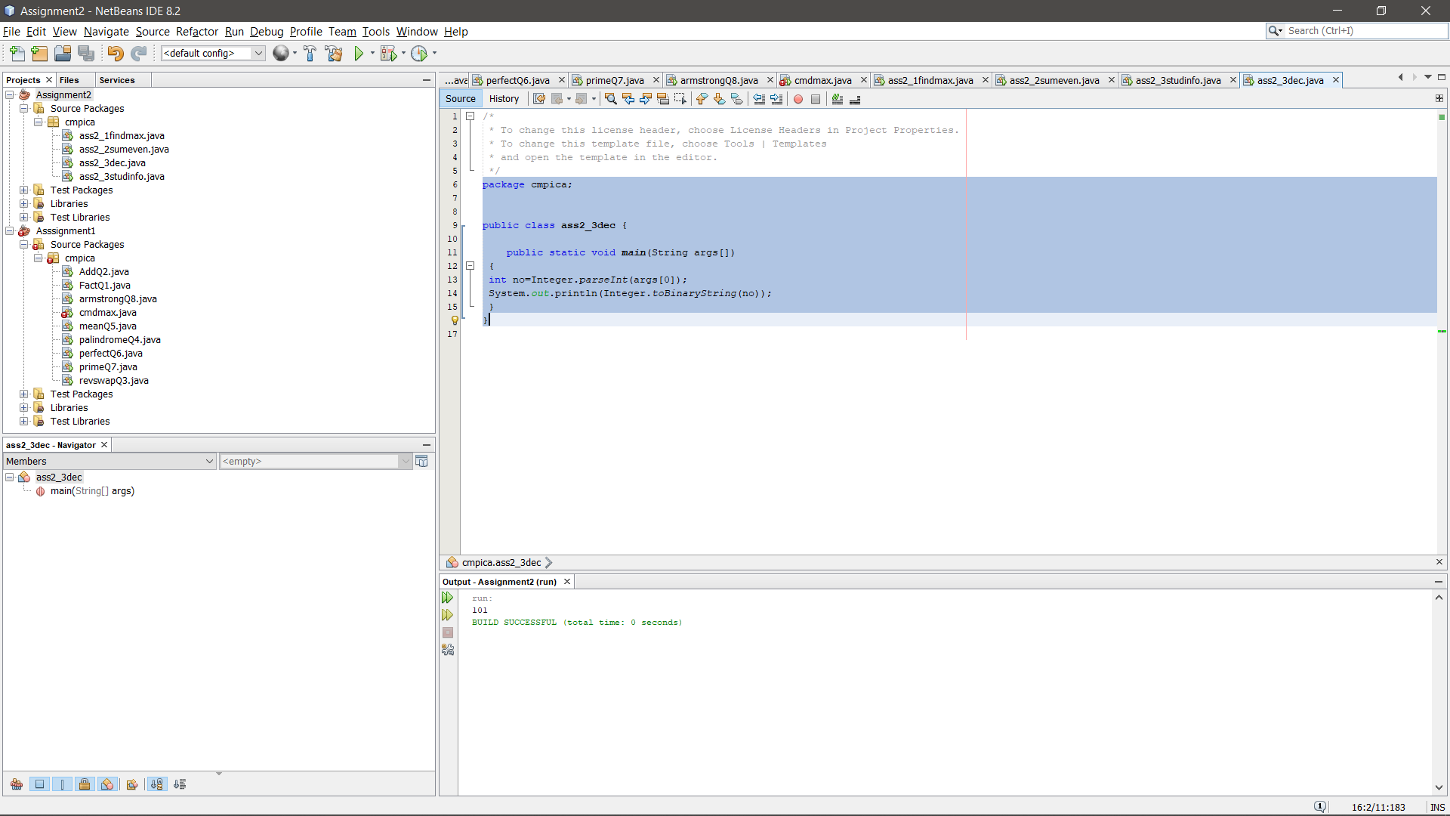

1. Write a java code convert Binaryl Number into Decimal Number using comand line arguement.

package cmpica;

public class ass2_5bindec {

public static void main(String[] args) {

int decimal=Integer.parseInt(args[0],2);

System.out.println(decimal);

}

}

INPUT: 1011:

OUTPUUT:

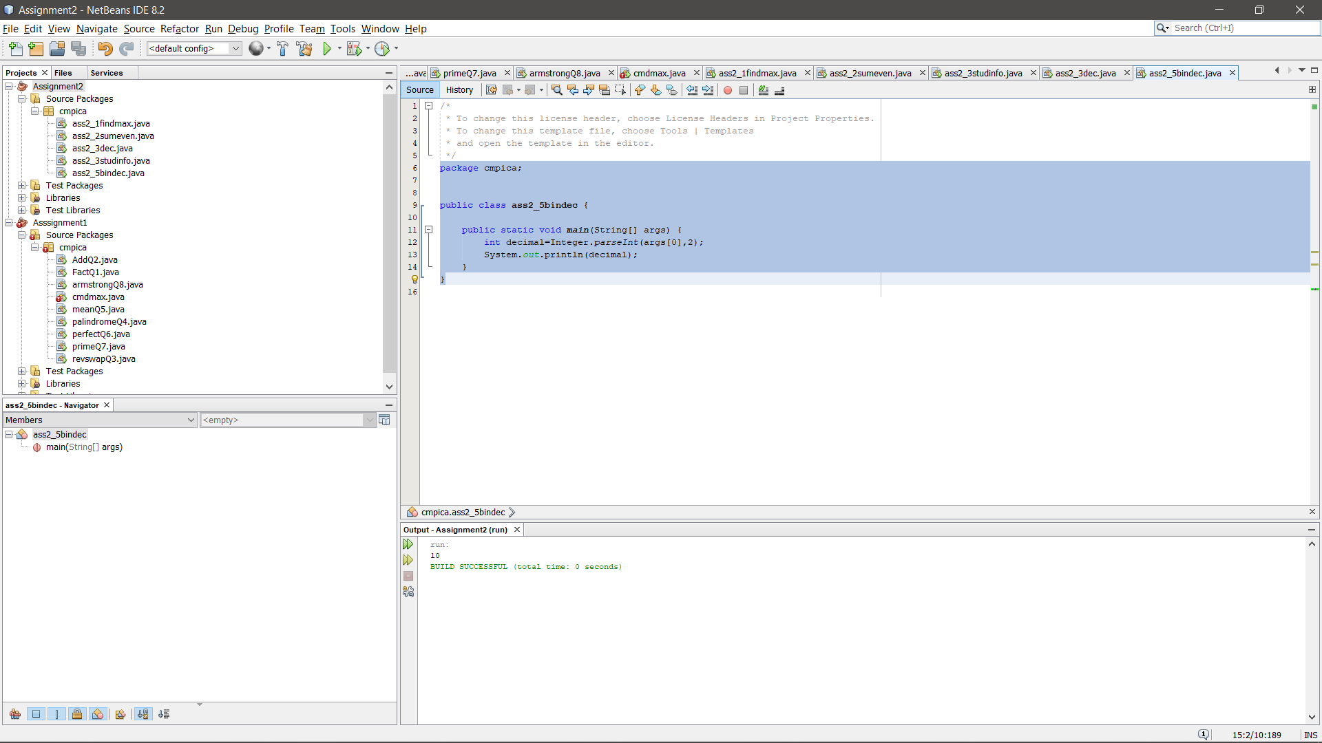

6. Write a program to print first and second digit. e.g. input 23516 output 2 3.

package cmpica;

class FindfirstAndSecondDigit{

public

int temp;

public void DisplayfirstAndSecondDigit(int temp)

{

int n=temp;

while (temp >= 10){

temp /= 10;

}

System.out.println("First Digit is: "+temp);

int temp2;

for(temp2=n; temp2>0;)

{

if (temp2 < 99) {

System.out.println("Second Digit is: "+temp2 % 10);

break;

}

else

{

temp2 = temp2 / 10;

}

}

}

}

public class ass2_6 {

public static void main(String args[])

{

int no1= Integer.parseInt(args[0]);

FindfirstAndSecondDigit f12D= new FindfirstAndSecondDigit();

f12D.DisplayfirstAndSecondDigit(no1);

}

}

INPUT: 1567

OUTPUT:

